# Sun-LockDown-Logo-200-x-200-Red.png

# 

Table of Contents

Description 2

Navigation Bar 2

Colours 3

Typography 3

Wireframe 4

Branding 4

# Description

This digital portfolio is a place for me to showcase my works and previous projects as well as offer my services and let people know about my abilities and myself as a person. It's a fairly basic site that has a navigation bar to navigate through the website and to view different pages. The website contains a Home, About Me, Projects, Services, Contact Me, and a Github page/link. Each page has the navigation bar at the top, and the footer with the copyright at the bottom. It's content is in the middle. Home and Contact me both have the Stay Connected portion which offers links to my Facebook, Twitter, and Google Plus pages. The home Page also contains a slideshow to showcase a few of my projects.

# Navigation Bar

The navigation bar is a very basic one that has links and a logo. The links will bring you to the page that you clicked on and the logo is just there to be all pretty. Other than that, there's not much to say about it. The Home link will take you to the home Page, the About page will that you to the About page, and so on.

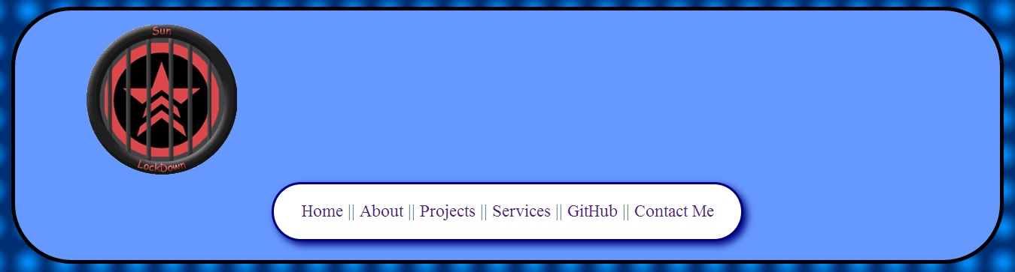

# Colours

The colour scheme I chose was a cool blue set. The darkest of these colours having a Hex value of # 002f74 (dark blue), and the lightest having a hex value of #ffffff (white). This range of colours allowed me to give more emphasis on the content and let the viewer still be able to read the content of the website just fine. The most common colour on my website other then the white has a hex value of #6699FF which is a lighter sky blue.

# Typography

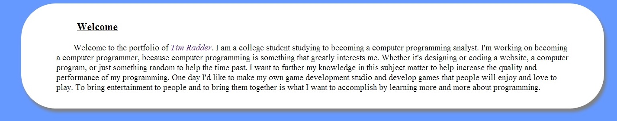

I just used the basic default font at size 20 for the body text, and a size 25 for the headers. The headers are also underlined. There's not much more to say about that.

# Wireframe

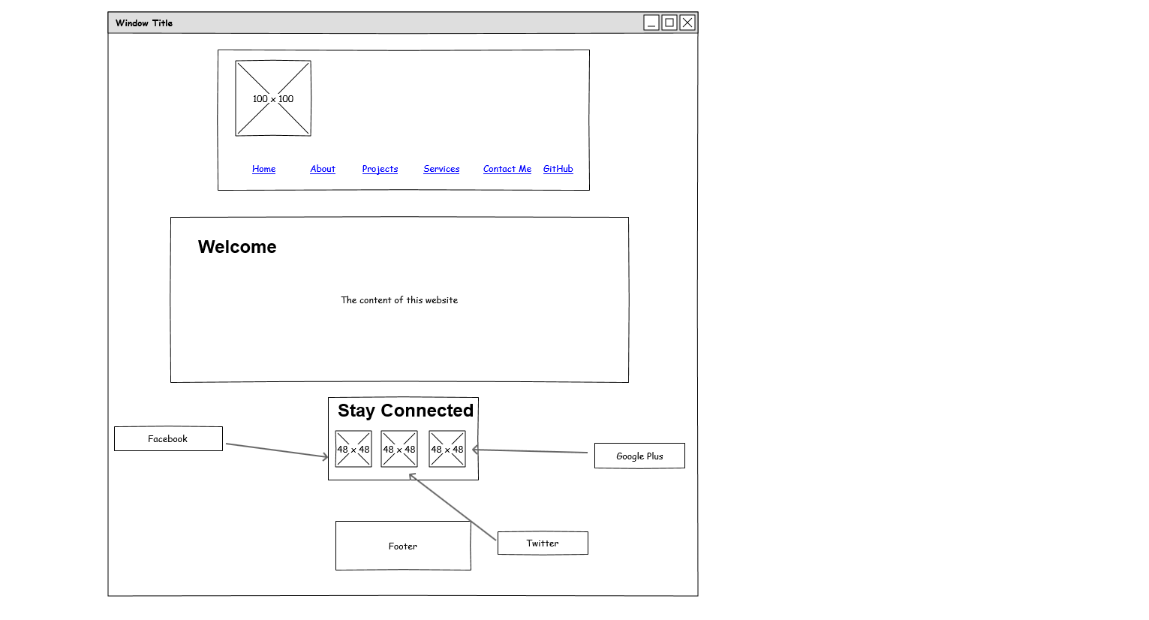

# Branding

